CodeYogi

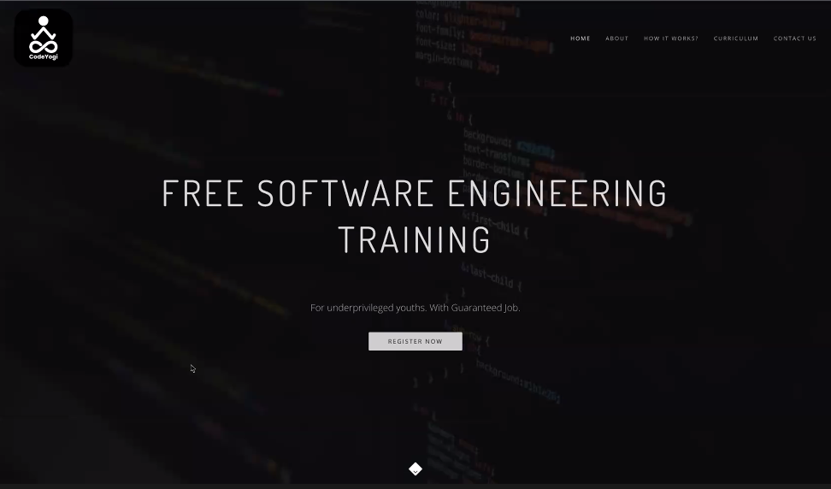

**Session 1**

**20th July 2022**

**What is smart phone?**Who understands new things and new content.

**What is App?**

It is a set of instruction which was performed.

**Video VS Video Game?**

Videos are dumbed, also it will create easy

Video games are dynamically in nature, it’s difficult to create.

**Steps to create a web App?**

* Learn language
* How to write programs in well manner.

**JavaScript is widely used language.**

After **JavaScript** we will learn a library called as **React.**

**A** library help us to make a work easy or give a template like functionality

**Before JavaScript we learn Html and Css.**

**Html ->** hypertext markup language.

**Css ->** Cascading Style Sheet.

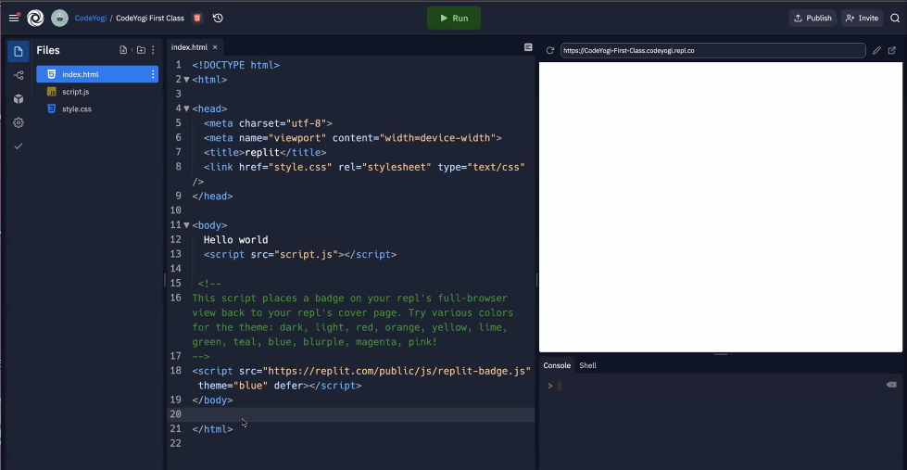

It’s a place where we write our code for website known as IDE -> **integrated development environments.**

**< words >** helps us to write the code also start and end the tags.

**<html> known as tag and also always in pair and some of them are self closing tags.**

**Tags:** Tags are fixed and sensible with well defined.

**Open Tag: <html>**

**Closed Tag: </html>**

Tags are aways come in couple and have a content in between.

**Syntax:**

**<html> Open html tag**

**………………………………………………………………………**

**……………………………Content…………………………**

**………………………………………………………………..........**

**</html> closed html tag**

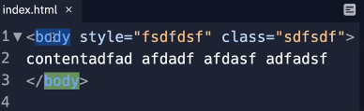

**<body style=”h1” class=”hello” >**

**………………………………………………………………………………**

**…………………………………Content………….……………………**

**……………………………………………………………………………**

**</body>**

**When you start an application… opening and closing tag**

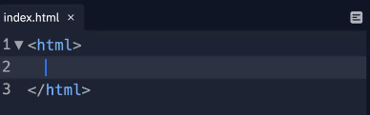

**Structure of the application or file**

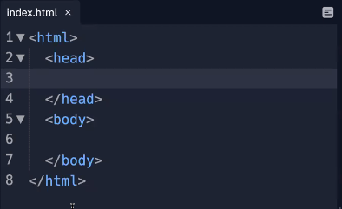

**Result of head Tag:**

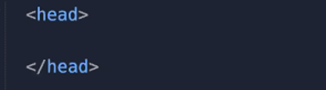

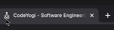

Nesting open and closed tag

**if you start the tag inside the other tag so you will close it only inside**

**h1 -> It is a main heading largest heading which was defined by the html developer.**

**Syntax:**

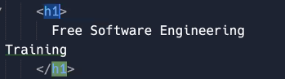

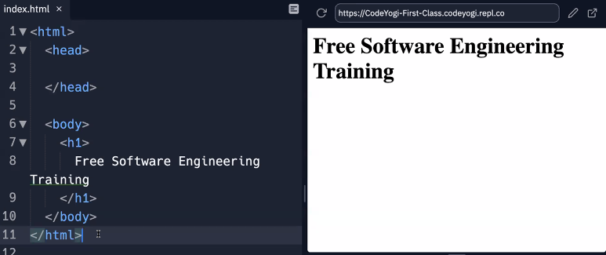

**h2, h3, h4, h5, h6 these all are the heading which was going smaller.**

**Syntax:**

**<p> content <p>**

**Like example: <p> hello how are you </p>**

**Note:**

**For simple website we can use also use drag and drop website only not for WebApps.**

**Practical till now:**

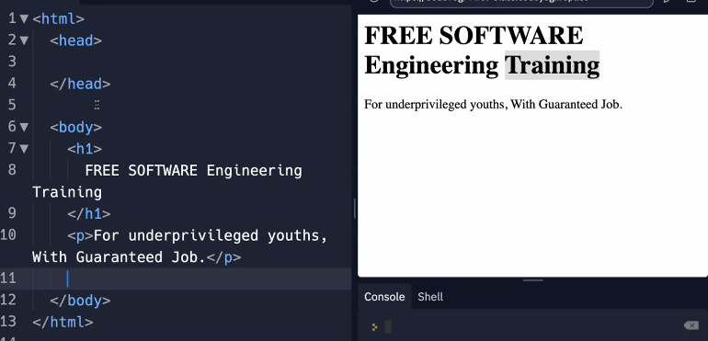

**NOTE:**

**Between tags space doesn’t matter.**

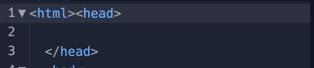

**You can write the code in a single line like that**

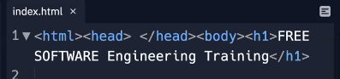

**But it looks like a nightmare, will not understands very well to the other developer but for computer it will never took a matter how you write code   
  
Computer will understand in any way but we will give proper space for our better understanding for future.**

**NOTE:** Always give a proper space between tags and always start a new tag from a very new line and always close the tag a very new line for better understanding.

**There are two thing for writing a code:**

* Rules -> it’s a mandatory to follow the rules
* Conventions -> it’s not a mandatory to follow

If we use the nesting tag we will always use the indentation and write a code in new line known as **code formatting.**

**Collapse**

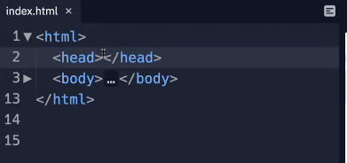

**How to create a button?**

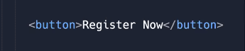

**Img Tag:** <img src=”url” /> self-closing tag

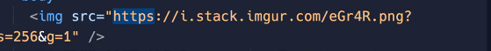

If you don’t want a button then you will use a **anchor tag** <a href=””> content </a>

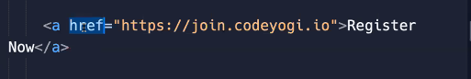

Attribute : it will helps us to customize the tags or change the behavior of that particular tag.

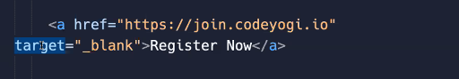

**Target attribute: help us to open that page in a new tab**

**Input Tag**

**textArea Tag**

**Inline Css use in h1 Tag:**

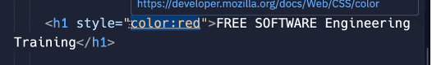

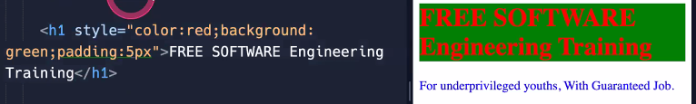

**Session 2**

**22th July 2022**

**5:11 pm class start**

**Syntax of input Tag**

**<input value=”@gmail.com” placeholder=”Enter your email” Type=”text”/>**

**It is an self closing tab value =”default value” placevalue=”hint value” type=”text”**

**The default value of the type is “text” and much more fixed type are there like:**

**Email , Password, Text, number, tel** 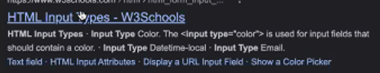

**5:27 p.m. TextArea**

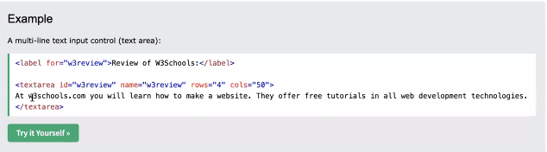

**Attribute**

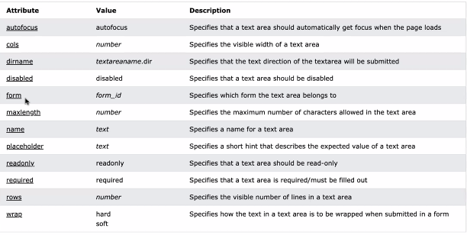

**<textarea>** Message **<textarea>**

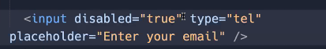

Those attribute are only have boolean value and bydefault value is **false** without write.

**Disabled = true**

If value and placeholder both will given at a time then show only value that time.

**5:35 p.m. Comment**

**Ctrl + /** == to comment the line.

To create a hint what we write

Also we want to comment the temporary code.

We will use the **Git** instead of comment

**5:45 p.m. Css**

**Style(property : value)**

**color**

**background**

**gradient**

**padding**

**screen is like a small bulb called as pixel**

**Note:**

**when we set a width then its bydefault to set the height automatically because of the aspect-ratio**

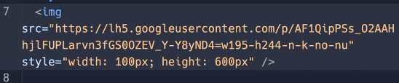

**Note :**

**We will not give both height and width at a time, only give one at a time so it will not strech.**

**Width: 50%** based on the parent tag

**6:00 p.m. ankor tag**

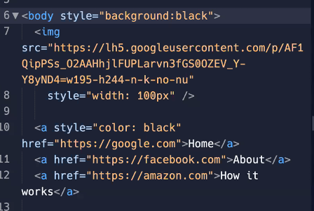

**Text-decoration: none**

**Margin: 30px;**

**Margin-right: 30px;**

**Why ankor tag is underlined?**

**In previous time css was not that much so that why at that time all the content with clickable make difference**

**RGB (0-255)**

**Hexadecimal 🡪 #33RREC**

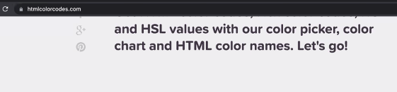



**NOTE:**

**We always note that first ankor not give any margin and rest of all the ankor will give left margin…….**

**6:36 p.m. Inline Vs block**

**Ankor tag 🡪** inline tag

**Img tag is in between the inline and block**

**h3,p 🡪** block tag.

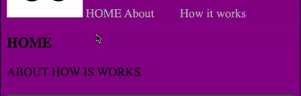

* **Inside Inline tag block element will come Vice-versa not possible**
* **On inline tag some property did not work margin top bottom height**

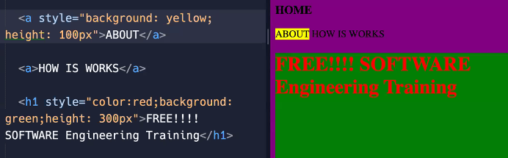

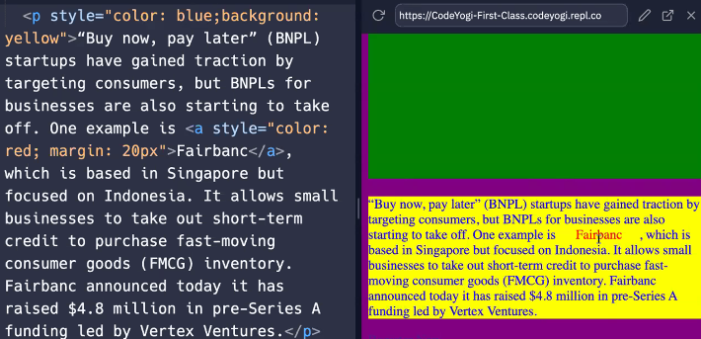

**Margin 🡪** space outside the boundary

**Padding 🡪**space inside the boundary

In block element will take space or background color according to the content

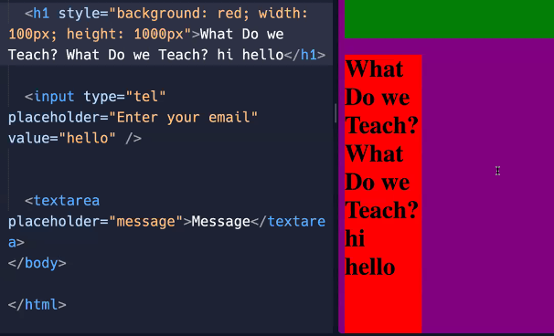

**Go outside the content**

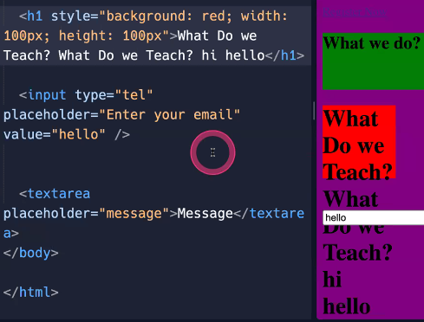

**Overflow: hidden;**

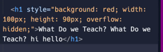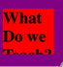

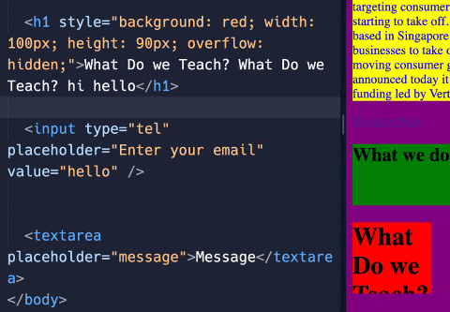

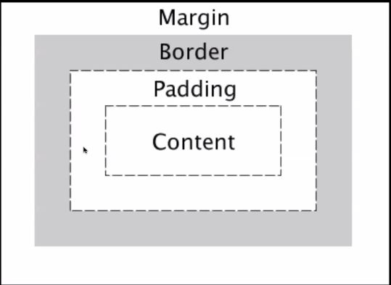

**Default height and width is given to the content error by developer.**

**Box- sizing: border-box; 🡪 it include all the space till full box**

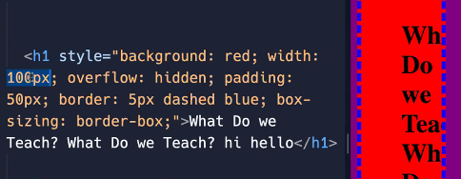

**Background color goes till border**

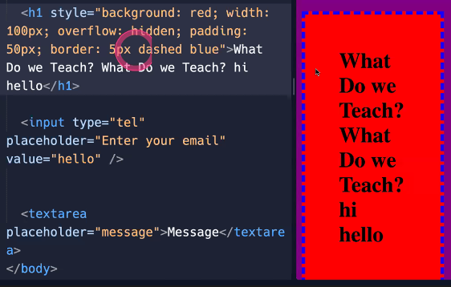

**7:35 p.m. span / div**

***Div* 🡪 block level element. It makes a group of inline elements**



***Span* 🡪 it help us to break the element.**



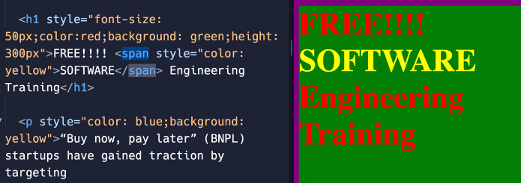

**Text-align:** centre;

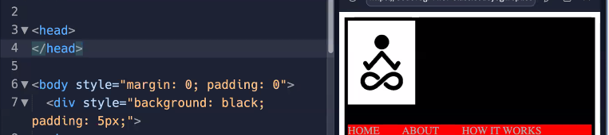

To remove the default margin and padding.

**Finish**

**Session 3**

**25th July 2022**

**Flex**

**Example of flex**

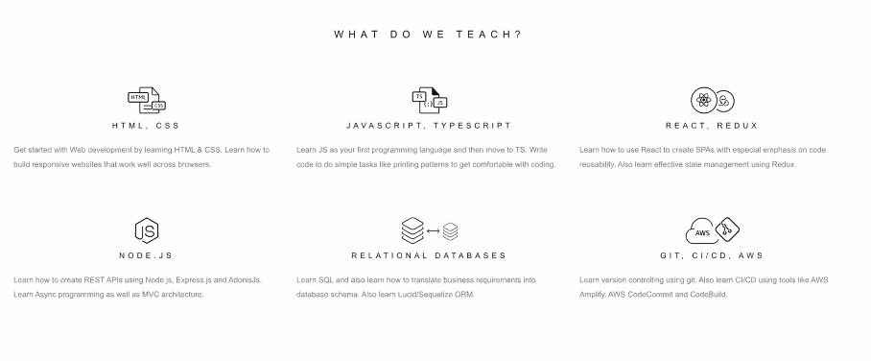

**Task: both come in a row**

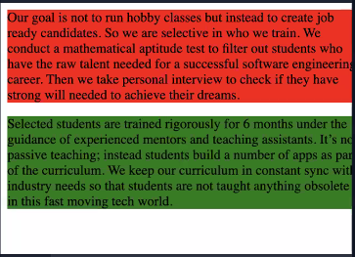

**When I give width:50%**

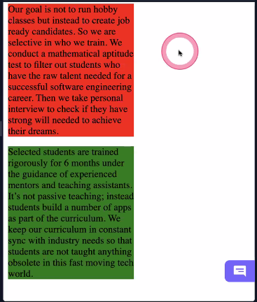

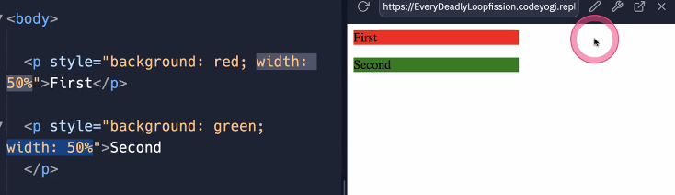

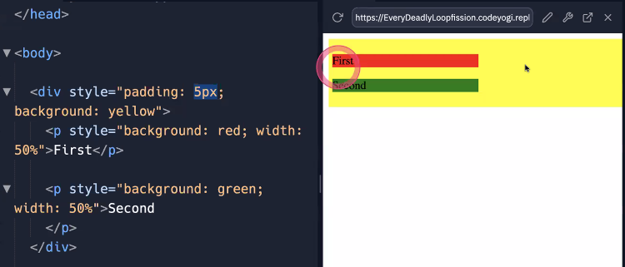

**Div took height according to the paragraph and content**

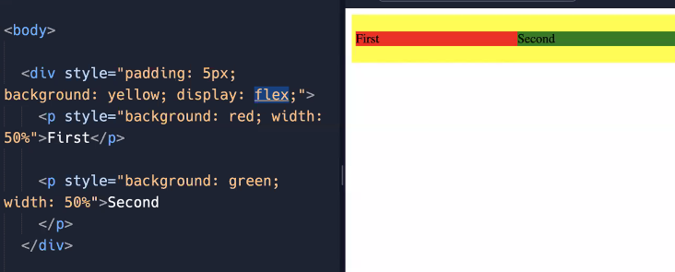

After adding **flex property**

**Div 🡪 flex box**

And inside item are **flex item**

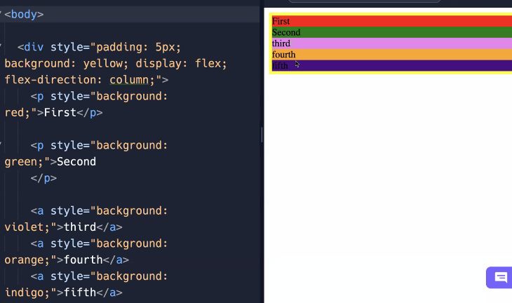

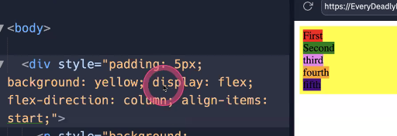

**Start , center , end;**

**Stretch is the default value**

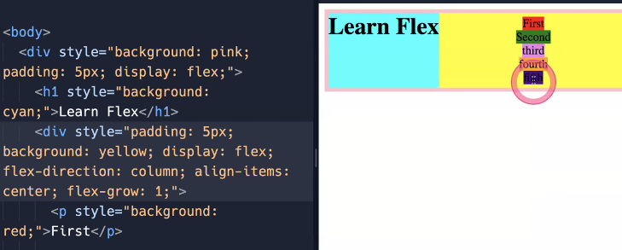

**Grandpa is control the parent not the child.**

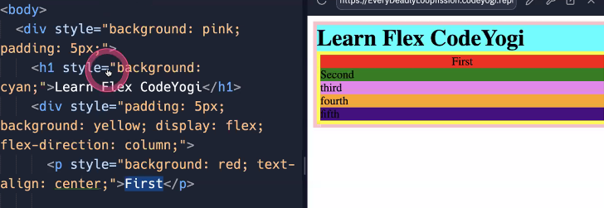

**Align-item: stretch** work in opposite direction

And also  **before that use need to be flex-box.**

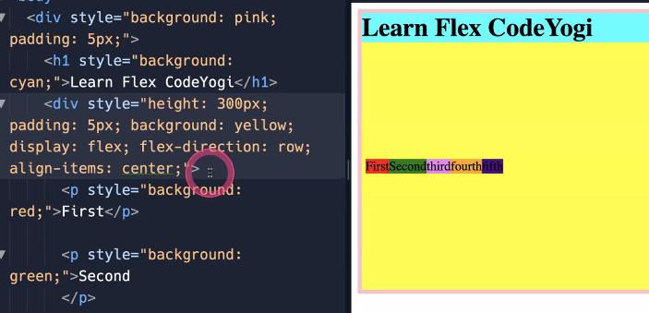

**Not works start center and end  
because it will work on vertically and have not any space to move start center and end**

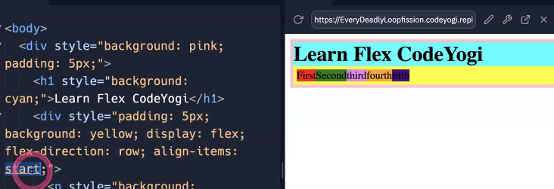

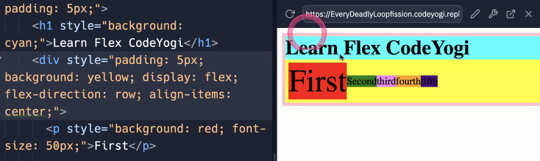

**Have a space to move start center and end**

**Align-item: opp. to flex direction**

**Justify-content: same direction to the flex**

**FLEX-direction: main axis (justify content)**

**FLEX-direction opp: cross axis (align item)**

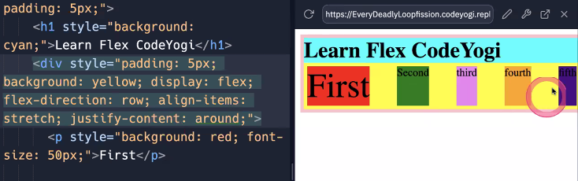

**Justify-content:**

**Space-around**

**Space-between**

**Space-evenly**

**Start**

**End**

**Center**

**Flex-grow: 1**

**Free space divided according to the percentage**

**Flex-bases: 0 (shrink) default**

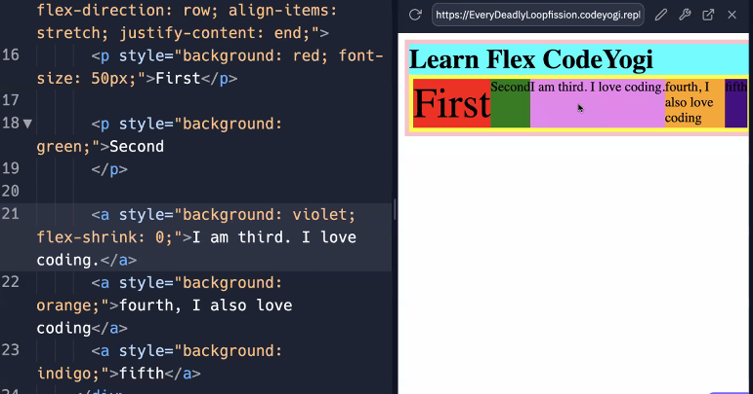

**IF any child want to move up and down**

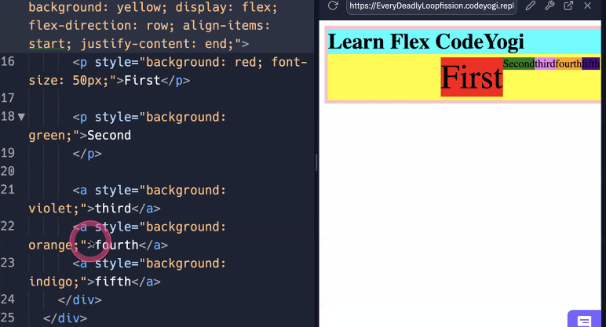

**Align-self: end;** only works when the parent is flex-box

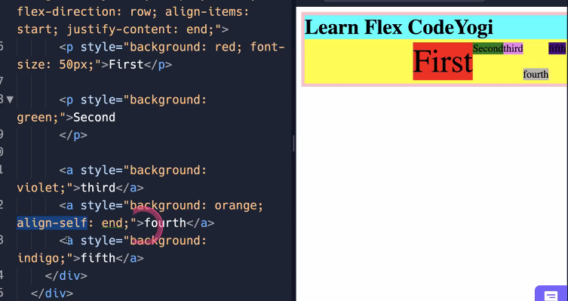

**Flex-direction: row-reverse.**

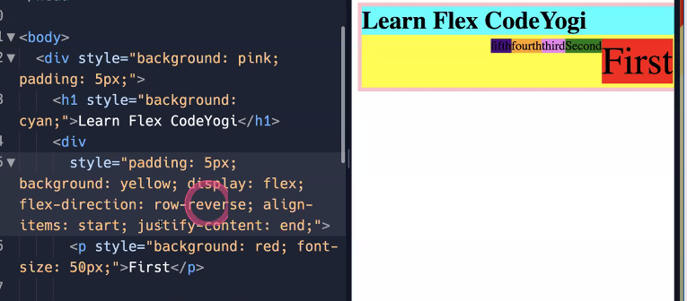

**6:35pm flex complete.**

**Doubts**

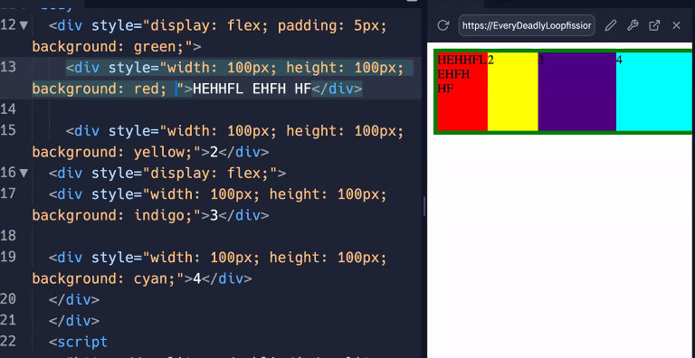

**Flex-wrap: wrap**

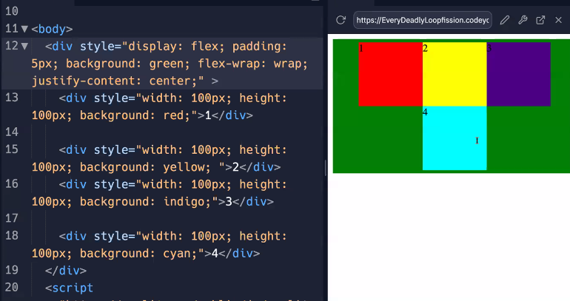

**Problem faced in the above use case.**

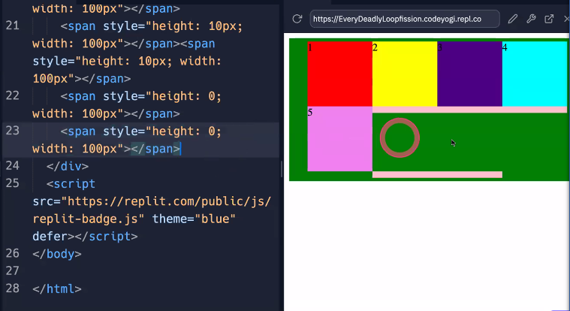

**No of Span = total no. of item -1**

**7:23pm important about the button.**

**Finish**

**Session 4**

**26th July 2022**

**Selectors**

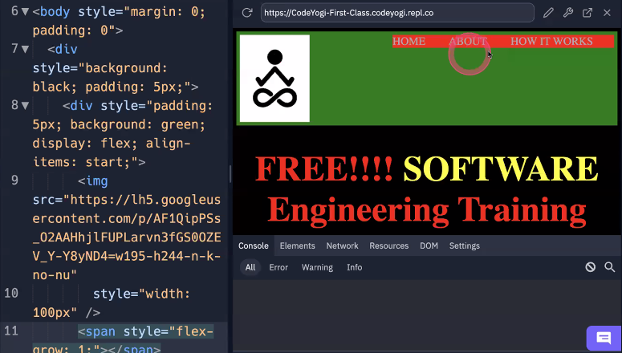

**<Span style=”flex-grow:1 “ > </span>**

**Justify-content : space-between**



**Task is: starting 3 come in start and last 2 come in end.**

**Span == spring is better in this case because it will come in a single div**

**HomeWork:**

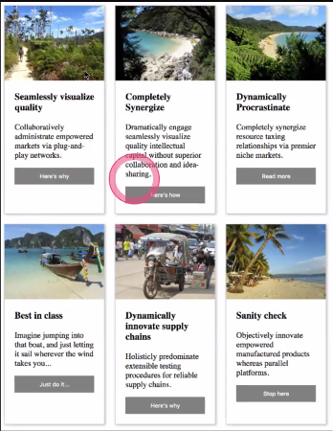

***Selectors:***

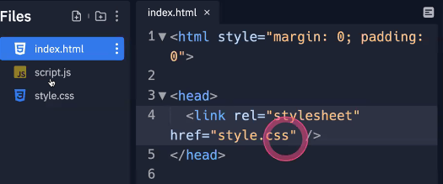

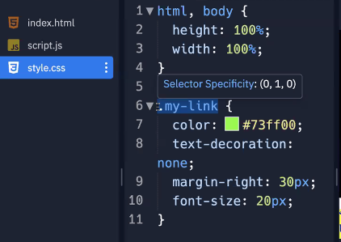

**Selectors**

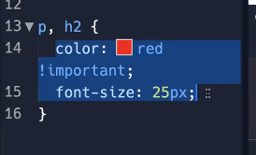

**Tag**

**Id=”roll-No”**

**Class=”top-link”**

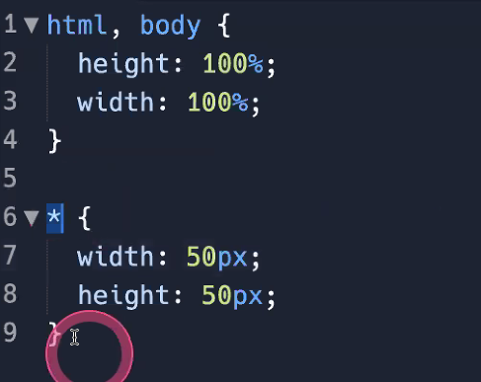

**Wildcard == all select.**

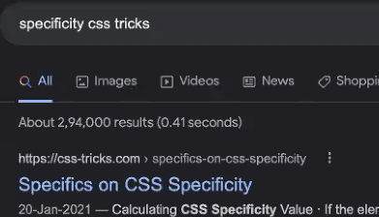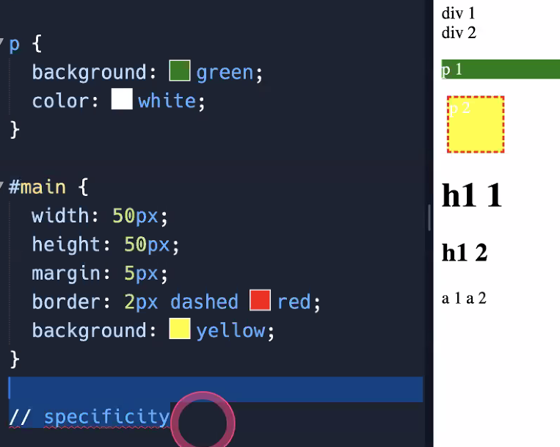

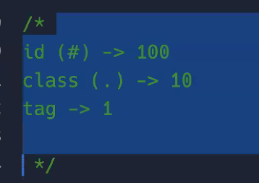

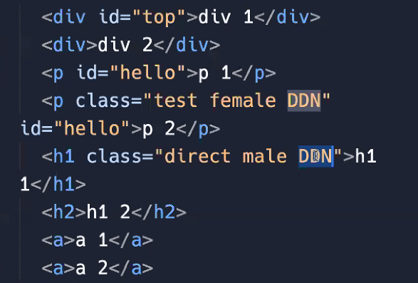

**If both were equally fight then win that who written last.**

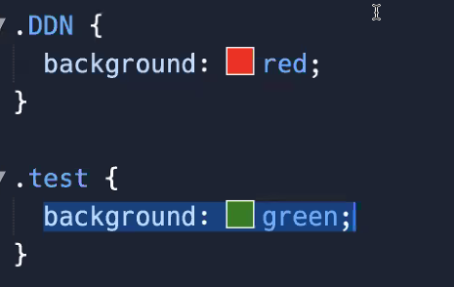

**It doesn’t matter the below**

**Order matter in css file not in html file**

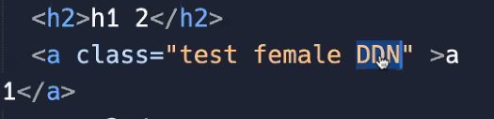

**Combination of selectors**

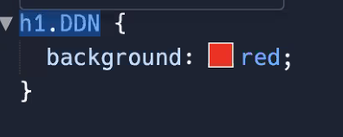

**All three conditions are true then it will apply that**

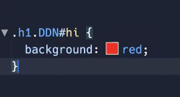

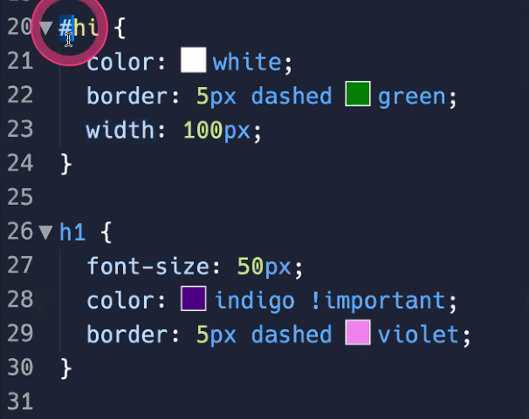

**Align item and align self**

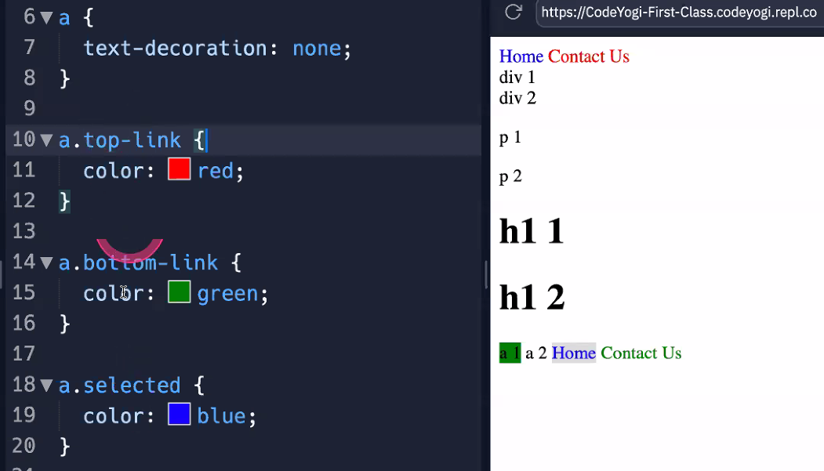

**.freefighter .child**

**.freefighter>.child**

**Session 5**

**29th July 2022**

**Tailwind css**

Way of writing css

1. Internal Css (hard work)
2. External (confusion with specificity)
3. Using inline <style> (hard work)
4. Using atomic classes(Tailwind)

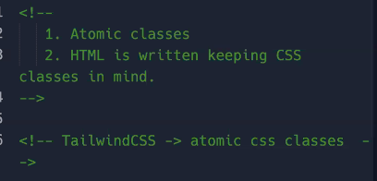

Atomic classes are defined by the open source developer

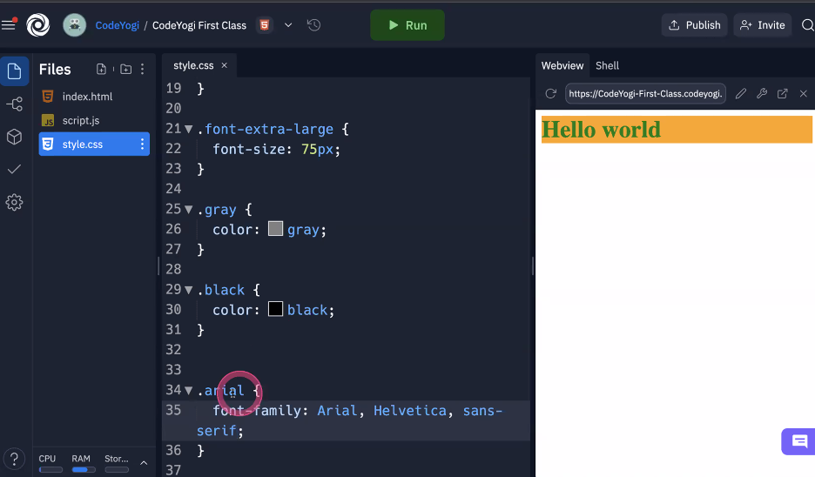

* Classes we have already written and write html on keeping css already written like atomic classes before we were writing html and write one class on it and change in the class of it.
* This approach seems like inline css and repetition is there .
* Repetition will be solved by react , vue, angular (js libraries) which can make reusable components and then we can use tailwind css . But that can be applied on inline as well but we need tailwind css to make responsive design, get consistency (by making some standard points for color and sizes) and also better than external because there is less confusion of specificity.
* 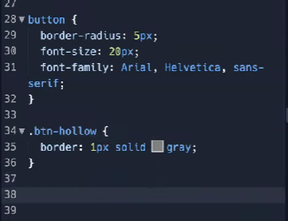
* **Common css write in a tag and specific css create a class**

Tailwind css looks like a inline css but we have a limit colors and size for a **particular** project and web app

**Inline css have not written the responsive the design and confusion will also remove by tailwind and react will remove that the repetition**

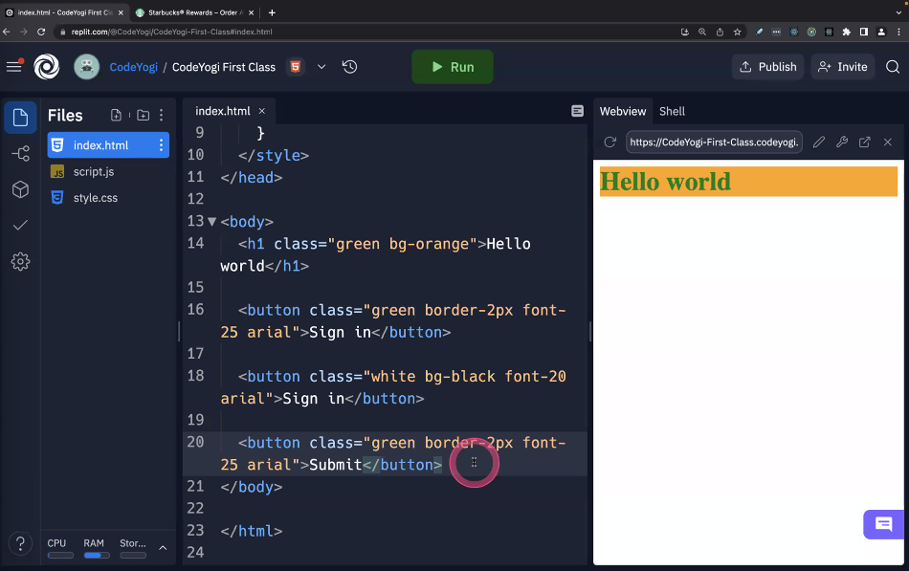

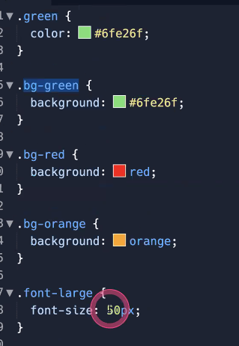

With tailwind we don’t need to write all css we have predefined libraries for that and can be directly used.

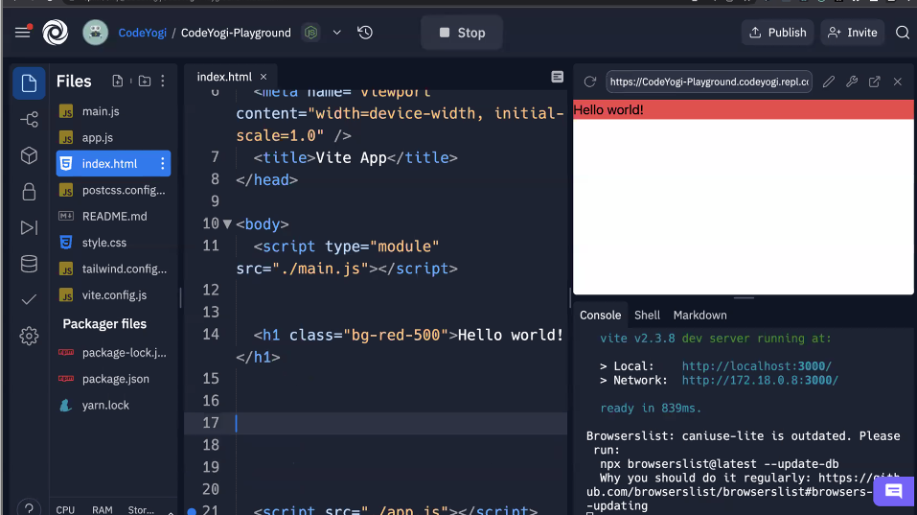

* tailwindcss.com



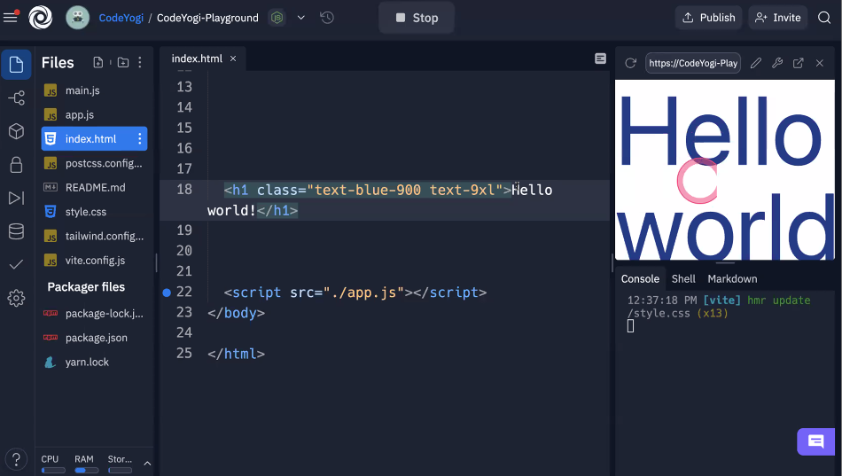

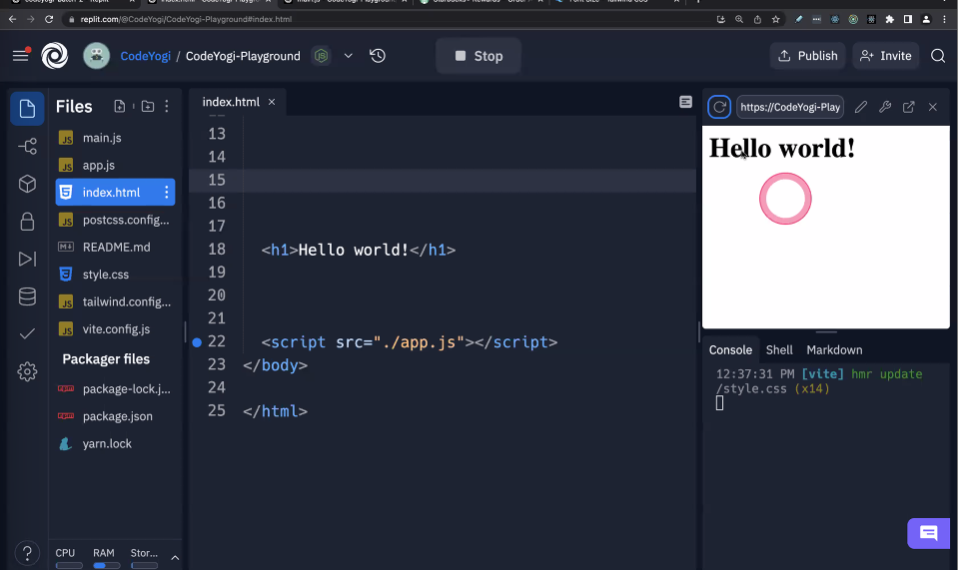

* Before it is showing default browser rules but tailwind has removed all default things.

To remove all default

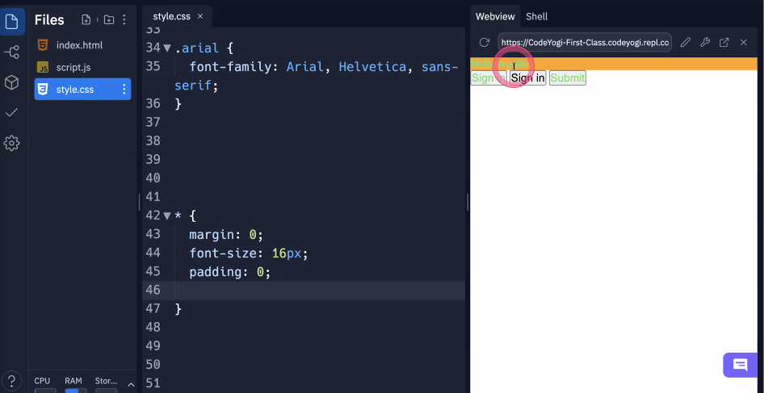

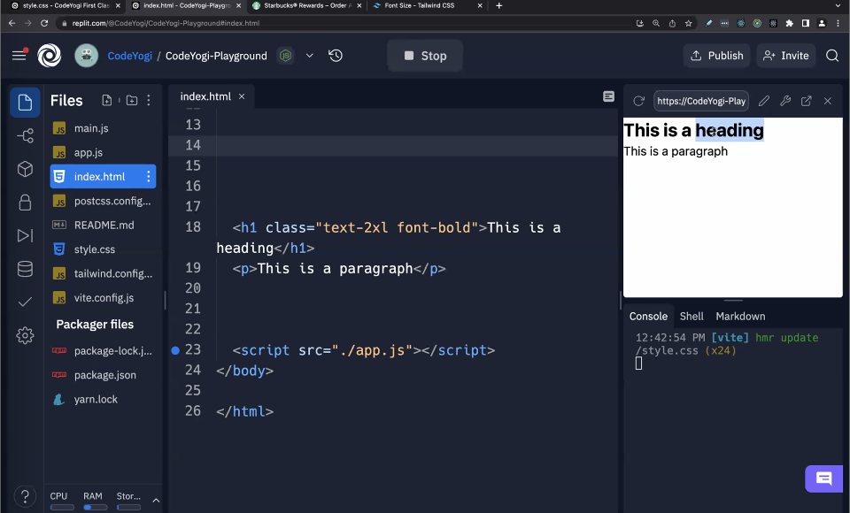

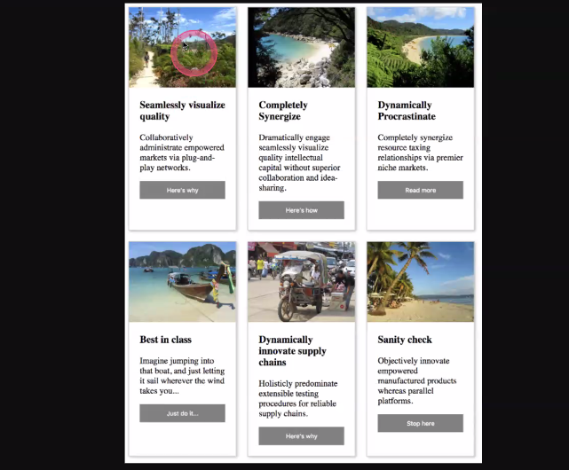

Text-black is color black and font-black is font extrabold

Padding : p , pl , pr , pt , pb , px , py ,

Margin when give space between siblings but use padding for child too get space

Use min-w-40 for giving min width and max-w-60 for giving max width

Never use width and fixed height instead use min width and max width

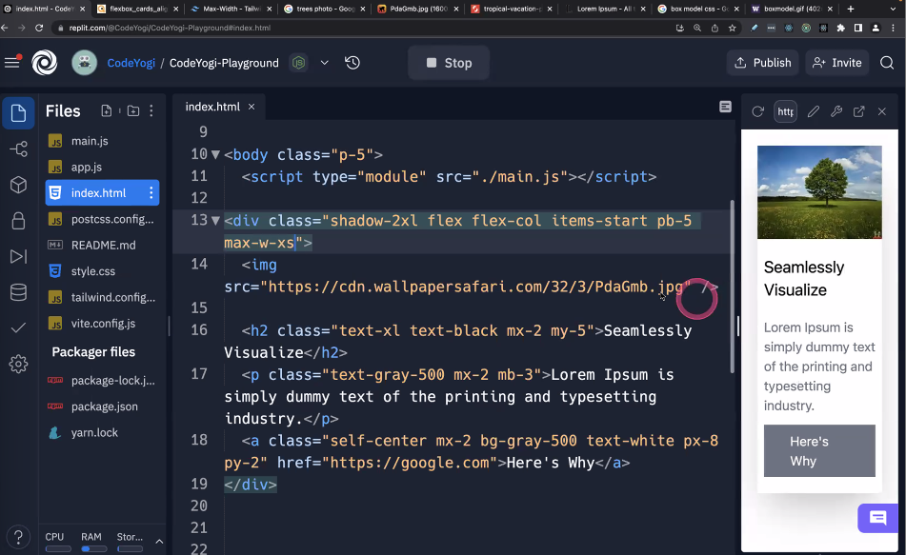

Space-x-2 and space-y-2 for giving space between children.

Flex-wrap for not changing div size

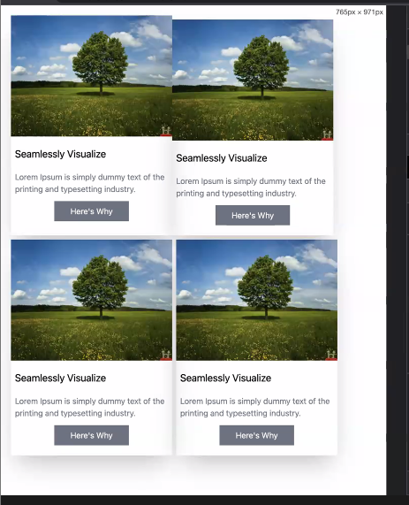

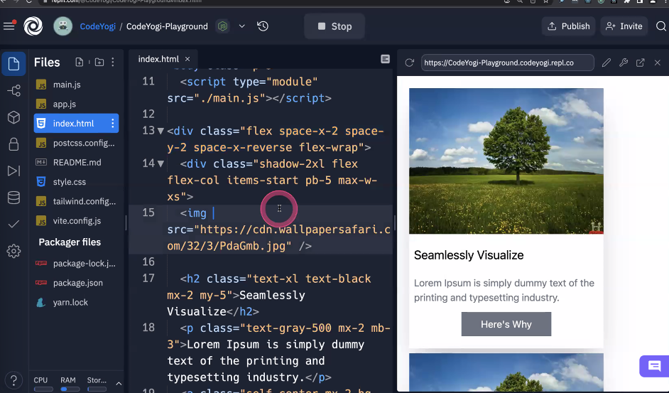

Use gap-2 for giving space between children instead of space because it gives in start as well

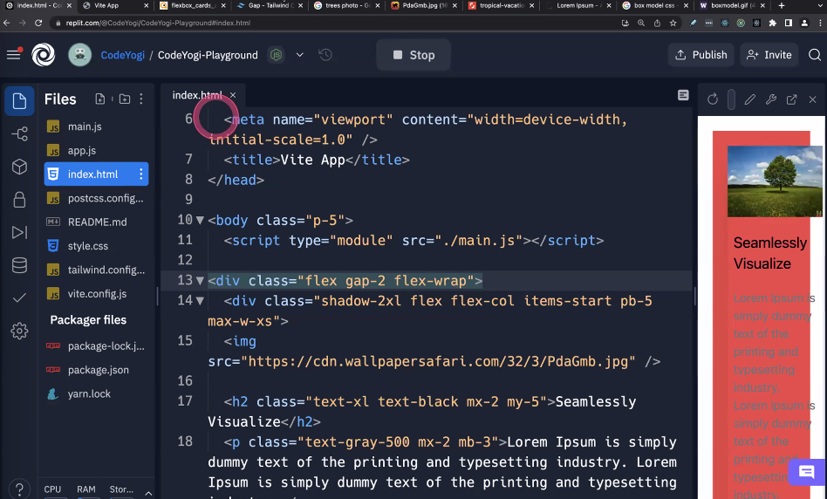

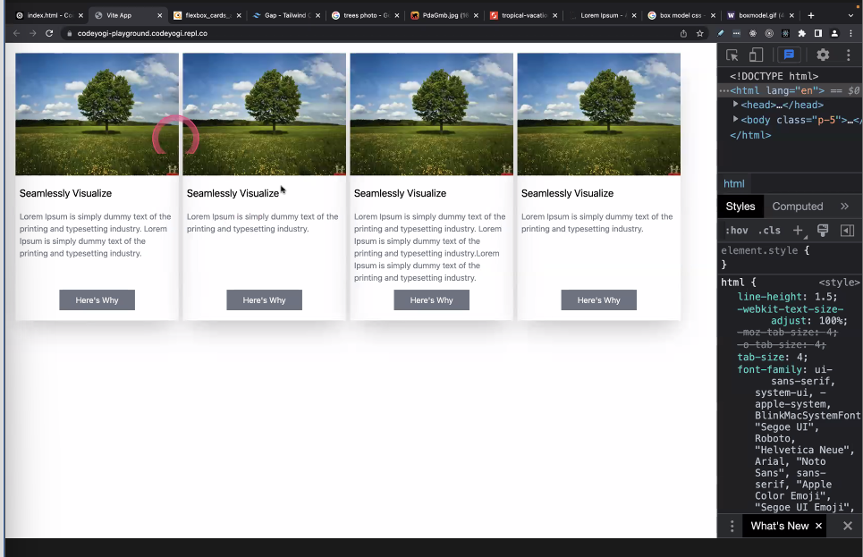

Tailwind labs

**…Finish…**

**1th August 2022**

**Session 6**

**Responsive**

**Design**

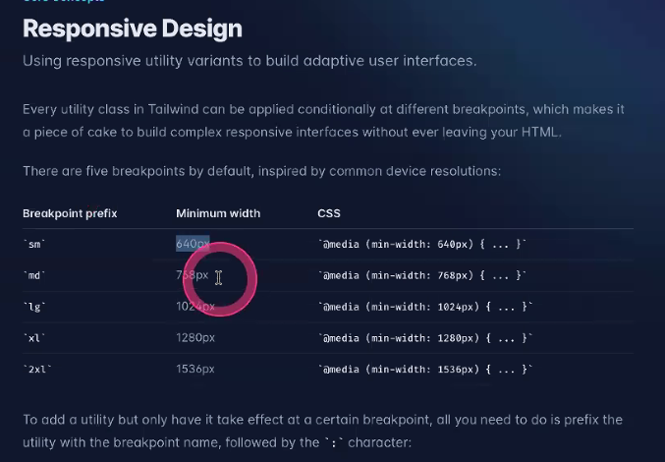

**Color are small in all screens,**

**Flex direction, padding , margin, font size these all are change.**

**3th July 2022**

**Session 7**

**javascript**

**Table printed through html**

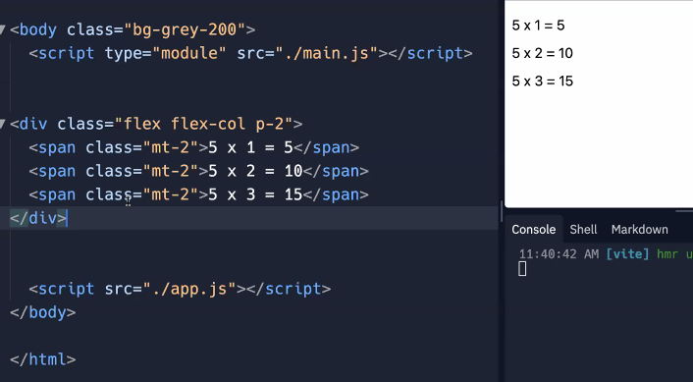

**In html and css, we can’t do it calculation**

**JavaScript**

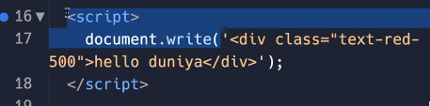

**With for loop in javascript** 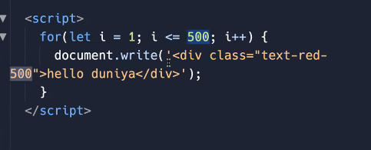

**With back quote and a variable**

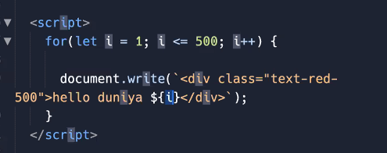

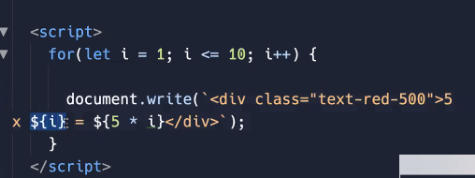

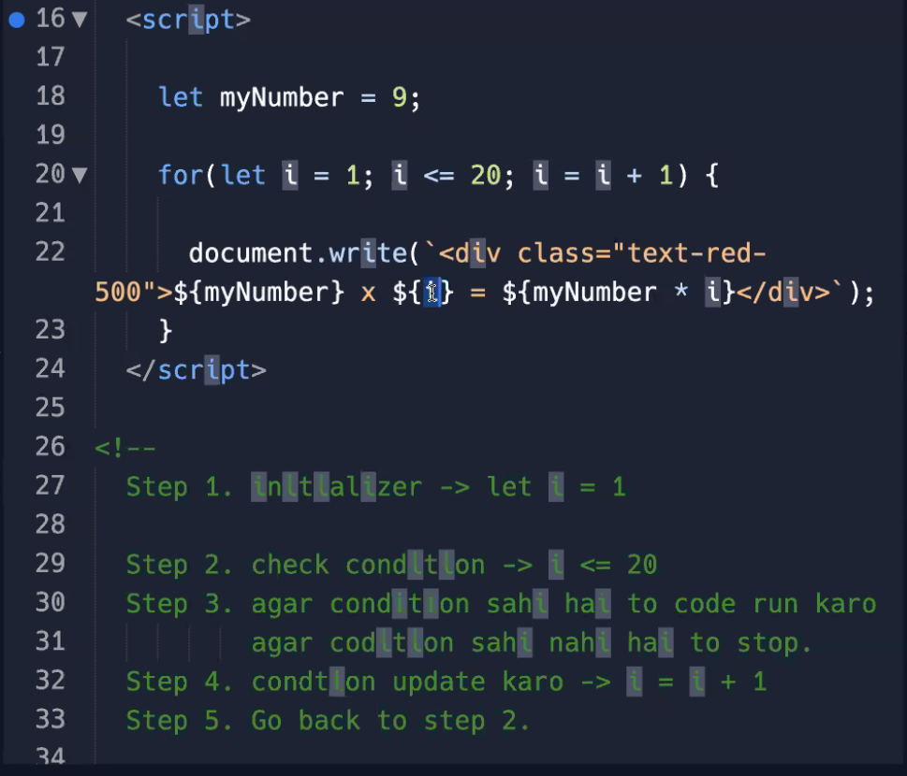

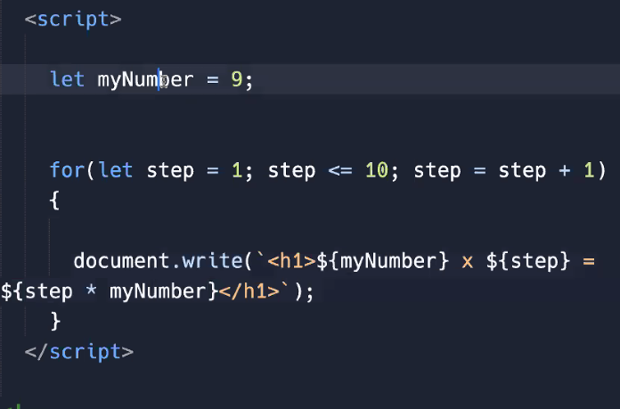

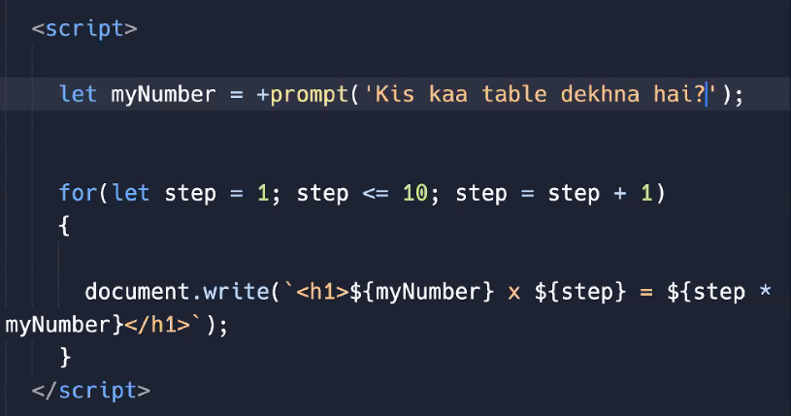

**Table till number**

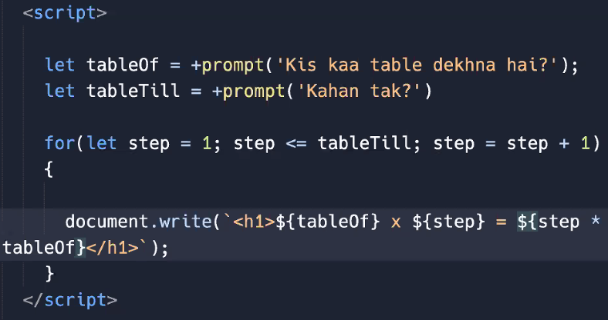

**Difference between single quote and none**

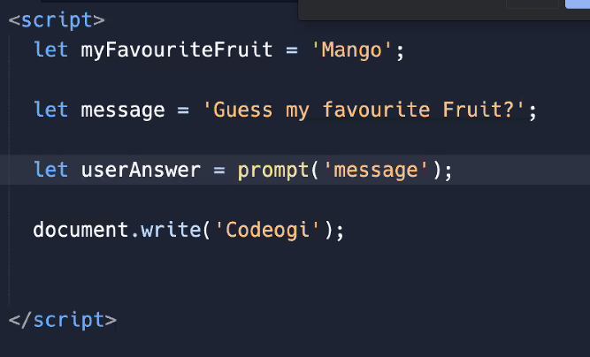

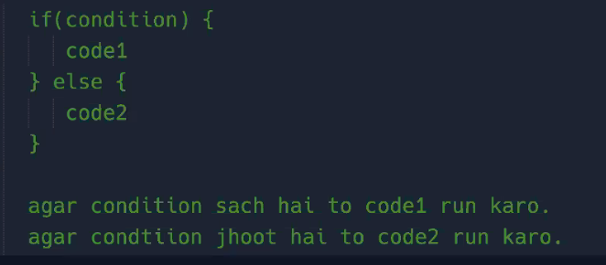

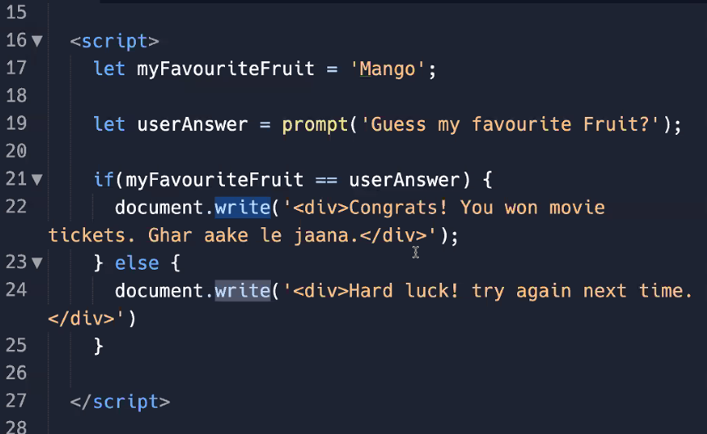

**Session 8**

**Javascript**

**5th August**

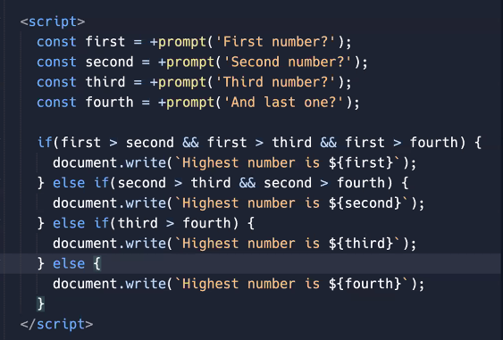

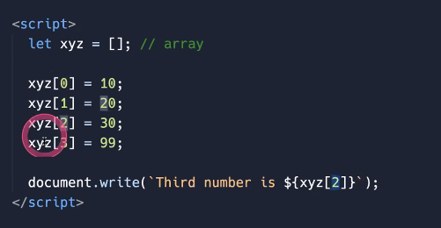

**We can store multiple value**

**We can override the value of the array with let datatype**

